 

***Software Requirement and Design Specifications***

**Embassy and Spy Tradecraft**

|  |  |
| --- | --- |
| *Course Code* | CS-324 |
| *Instructor* | Syeda Rubab Jaffar |
| *Project Team* | Saad Javed, 18K-0204  Yougesh, 18K-0290  Faraz Sarwar, 18K-1182 |
| *Submission Date* | 21st December, 2020 |



*Table of Contents*

1. INTRODUCTION 5
   1. Purpose of Document 5
   2. Intended Audience 5
2. OVERALL SYSTEM DESCRIPTION 6
   1. Project Background 6
   2. Project Scope 6
   3. Not In Scope 6
   4. Project Objectives 6
   5. Stakeholders 6
   6. Operating Environment 6
   7. System Constraints 6
   8. Assumptions & Dependencies 6
3. EXTERNAL INTERFACE REQUIREMENTS 7
   1. Hardware Interfaces 7
   2. Software Interfaces 7
   3. Communications Interfaces 7
4. FUNCTIONAL REQUIREMENTS 8
   1. FUNCTIONAL HIERARCHY 8
   2. Use Cases 8
      1. Embassy and Spy Tradecraft 8
5. NON-FUNCTIONAL REQUIREMENTS 9
   1. Performance Requirements 9
   2. Safety Requirements 9
   3. Security Requirements 9
   4. User Documentation 9

SDS 10

1. SYSTEM ARCHITECTURE 11
   1. SYSTEM LEVEL ARCHITECTURE 11
2. DESIGN STRATEGY 11
3. DETAILED SYSTEM DESIGN 11
   1. DATABASE DESIGN 11

8.2 . APPLICATION DESIGN 12

1. REFERENCES 12
2. APPENDICES 12

## Introduction

##### Purpose of Document

The System Requirement and Design Specification (SDS) will provide detailed description about Embassy and Spy Tradecraft System. The SDS will explain the purpose and scope of project and also include the features of the system and the different interfaces of the system

##### Intended Audience

This document is intended for the users and for the developing team

##### Definition of Terms, Acronyms and Abbreviations

|  |  |
| --- | --- |
| ***Term*** | ***Description*** |
| *SMTP* | *Secure Mail Transfer Protocol* |
| *HTTP* | *Hyper Text Transfer Protocol* |
| *ERD* | *Entity Relationship Diagram* |
| *MAC* | *Macintosh* |
| *OS* | *Operating System* |
|  |  |
|  |  |
|  |  |

##### Document Convention

##### Font-size = 12

##### Font Name = Arial

## Overall System Description

##### Project Background

##### The project is based on a typical embassy management system with a hidden taste of espionage. Currently, In Embassy there is lack of communication between spies, diplomats and other staff and also spies and diplomats face difficulty in finding out their assets within the particular country.

##### Project Scope

##### The project is based on the idea of embassy system. The system is divided into two parts one for naïve users which can be used by users to apply for visa and other for spies to communicate encode decode and interact with database, update, insert, delete, records of spies and their assets.

##### 

##### Not In Scope

##### The system will not authenticate the data entered by user through Nadra’s official application programming interface. The Script will only be able to verify the data based on its following of constraints.

##### 

##### Project Objectives

The goal is to provide the spies and diplomats with a cryptography based uncrackable communicating platform. This system also provide spies and diplomates platform which helps them to find out their assets within the particular country.

This System also provides basic functionality of typical Embassy Management system like apply for visa, visa application process and passport validation systems etc.

##### Stakeholders

##### 

##### Developers

##### Software Quality Analyst

##### Users (Spies, Diplomates, Visa applicant)

##### Project Manager

##### Operating Environment

The system is web-based Application which can be hosted on Windows, Linux and MAC OS.

##### System Constraints

* + - * + Web Browser Applicable.
        + No Hardware constraints at all.
        + Language: English
        + No legal constraints at all
        + Online Based System

##### Assumptions & Dependencies

* + - * + Initially, it is assumed that Spies that have access to the hidden functionality are registered prior to deploying system
        + Internet, Centralized Database Management System.

## External Interface Requirements

##### Hardware Interfaces

##### The hardware devices needed are monitor, keyboard, mouse. The user should have their own personal computers, laptop etc.

##### Software Interfaces

**User Interface:**

**-**Apply for VISA

**-**About Page

**-**Contact US page

**Spy Interface:**

**-**Spy Panel

**-**Message Encode/ Decode page

**Admin Interface:**

-Admin Panel

-Add news / Blogs

##### Communications Interfaces

The system will use a HTTPS based network protocol. The safe and secure email protocol SMTP would be used to send the email over the internet connection

## Functional Requirements

##### Functional Hierarchy

-User can view home page, read blogs/news, and can apply for visa.

-System internally verifies the visa details after that it will award status accepted or rejected.

-If It gets accepted then system will insert his/her details into the national database of visa holders and he/she is displayed a message with his/her visa details.

-If it gets rejected then user can exit the application and can reapply for visa.

-Admins can log into their admin panels

-Each admin needs to enter his credentials i.e. username and password to login to his/her admin panel. After logging into admin panel, admin can add a new blog or news or message to the website.

-Spy can encode and decode a secret message using various methods such as base64 encryption.

-Spies can also insert, delete, update and manage records of new spies, assets, diplomats, and agents.

‘

##### Use Cases

***4.2.1. Embassy and Spy Tradecraft***

]

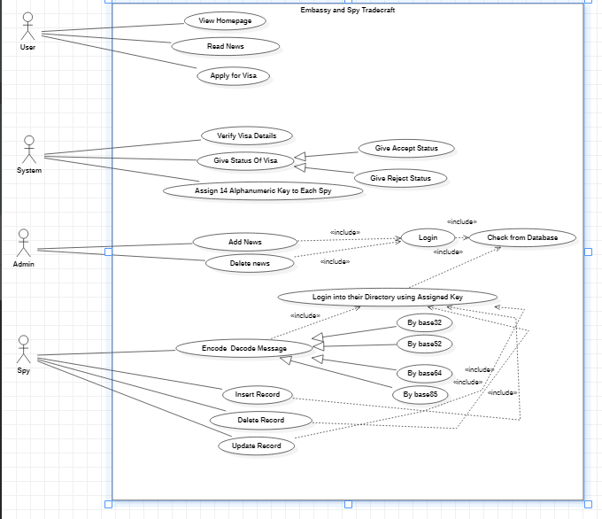

|  |  |
| --- | --- |
| ***Use Case Description*** | |
| ***Use Case name:* User can view Homepage** |  |
| ***Use Case Description:* User can View Homepage** | |
| ***Primary actor:* User, System** | ***Other actors:*** |
| ***Stakeholders:* User, System** |  |
| ***Relationships***   * ***Includes:*** * ***Extends:*** | |
| ***Pre-conditions:***  User Must Exist | |
| ***Flow of Events:***   1. User can view home page. | |
| ***Alternative and exceptional flows:*** | |
| ***Post-conditions:*** | |

|  |  |
| --- | --- |
| ***Use Case Description*** | |
| ***Use Case name: Read News*** |  |
| ***Use Case Description:* User can view blogs and read news available on the embassy website.** | |
| ***Primary actor:* User** | ***Other actors: Admin*** |
| ***Stakeholders:*** |  |
| ***Relationships***   * ***Includes:*** * ***Extends:*** | |
| ***Pre-conditions:***  User Must Exist.  News Must Exist | |
| ***Flow of Events:***  1.User can read news. | |
| ***Alternative and exceptional flows:*** | |
| ***Post-conditions:*** | |

|  |  |
| --- | --- |
| ***Use Case Description*** | |
| ***Use Case name:* Apply for Visa** |  |
| ***Use Case Description:* User can Apply for Visa** | |
| ***Primary actor:* User, System** | ***Other actors:*** |
| ***Stakeholders:* User, Visa applicants** |  |
| ***Relationships***   * ***Includes:*** * ***Extends:*** | |
| ***Pre-conditions:***  User Must Exist  User Must Have Passport. | |
| ***Flow of Events***  User:   1. Enter Details. 2. Get status   System:   1. Verify Details. 2. Give Status   . | |
| ***Alternative and exceptional flows:***  2.1  If a user gets accepted, his/her details are entered into national database of visa holders, and he/she is displayed a message with his/her visa details.  2.2  If it gets rejected, the user can either exit the application or re-apply for visa. | |
| ***Post-conditions:*** | |

|  |  |
| --- | --- |
| ***Use Case Description*** | |
| ***Use Case name:* Verify Details** |  |
| ***Use Case Description:* Verify User details which are provided for Visa** | |
| ***Primary actor:* System, User** | ***Other actors:*** |
| ***Stakeholders:* System, User** |  |
| ***Relationships***   * ***Includes:*** * ***Extends:*** | |
| ***Pre-conditions:***  User Must Exist and Provide Details | |
| ***Flow of Events:***   1. User enters details. 2. System Verifies Details. | |
| ***Alternative and exceptional flows:***  2.1 If Missing Information then Prompts user that there is missing information. | |
| ***Post-conditions:***  Details Must be Verified. | |

|  |  |
| --- | --- |
| ***Use Case Description*** | |
| ***Use Case name:* Give Status** |  |
| ***Use Case Description:* System will give status either accept or reject** | |
| ***Primary actor:* User, System** | ***Other actors:*** |
| ***Stakeholders:* User, System** |  |
| ***Relationships***   * ***Includes:*** * ***Extends:*** | |
| ***Pre-conditions:***  Details must be provided | |
| ***Flow of Events:***   1. System verifies details and give status either accept or reject. | |
| ***Alternative and exceptional flows:*** | |
| ***Post-conditions:***  Status Must be Awarded. | |

|  |  |
| --- | --- |
| ***Use Case Description*** | |
| ***Use Case name:* Add news** |  |
| ***Use Case Description:* Admin can Add news** | |
| ***Primary actor:* Admin, System** | ***Other actors:*** |
| ***Stakeholders:* Admin, System** |  |
| ***Relationships***   * ***Includes:* Login check if admin credentials are correct.** * ***Extends:*** | |
| ***Pre-conditions:***  Admin Must exist. | |
| ***Flow of Events:***   1. Admin logs in by entering username and password. 2. Admin adds news | |
| ***Alternative and exceptional flows:***   * 1. If Username or Password is incorrect, display message that username or password incorrect. | |
| ***Post-conditions:***  News Must be Added. | |

|  |  |
| --- | --- |
| ***Use Case Description*** | |
| ***Use Case name:* Delete News** |  |
| ***Use Case Description:* Admin can delete news** | |
| ***Primary actor:* Admin, System** | ***Other actors:*** |
| ***Stakeholders:* Admin, System** |  |
| ***Relationships***   * ***Includes:* Login check if admin credentials are correct.** * ***Extends:*** | |
| ***Pre-conditions:***  Admin Must be exist.  News must be exist. | |
| ***Flow of Events:***   1. Admin enters Username and password. 2. Admin deletes news | |
| ***Alternative and exceptional flows:***   * 1. If Username or Password is incorrect, display message that username or password incorrect. | |
| ***Post-conditions:*** | |

|  |  |
| --- | --- |
| ***Use Case Description*** | |
| ***Use Case name:* Encode or Decode Message** |  |
| ***Use Case Description:* Spy can encode and decode messages and strings.** | |
| ***Primary actor:* Spy, System** | ***Other actors:*** |
| ***Stakeholders:* Spy, System** |  |
| ***Relationships***   * ***Includes:* Login Spy Must be Logged into their hidden Directory.** * ***Extends:*** | |
| ***Pre-conditions:***  Spy Must exist  Spy Must be logged in. | |
| ***Flow of Events***   1. Spy enters details i.e user, password. 2. System Verifies details. 3. Spy can Encode or Decode message. | |
| ***Alternative and exceptional flows:***   * 1. If Details are incorrect prompts message. | |
| ***Post-conditions:***  Message Must be Decoded or Encoded. | |

|  |  |
| --- | --- |
| ***Use Case Description*** | |
| ***Use Case name:* Insert Record** |  |
| ***Use Case Description:* Spy can insert New record.** | |
| ***Primary actor:* Spy, System** | ***Other actors:*** |
| ***Stakeholders:* Spy** |  |
| ***Relationships***   * ***Includes:* Login Spy Must be Logged in their hidden Directory.** * ***Extends:*** | |
| ***Pre-conditions:***  Spy Must Be exist  Spy Must be logged in. | |
| ***Flow of Events***   1. Spy enters details i.e Assigned Key. 2. System Verifies details. 3. Spy can insert the Record. | |
| ***Alternative and exceptional flows:***   * 1. If Details are incorrect prompts message. | |
| ***Post-conditions:***  Record Must be Inserted in Database. | |

|  |  |
| --- | --- |
| ***Use Case Description*** | |
| ***Use Case name:* Delete Record** |  |
| ***Use Case Description:* Spy can Delete record.** | |
| ***Primary actor:* Spy** | ***Other actors:*** |
| ***Stakeholders:* Spy** |  |
| ***Relationships***   * ***Includes:* Login Spy Must be Logged in their hidden Directory.** * ***Extends:*** | |
| ***Pre-conditions:***  Spy Must Be exist  Spy Must be logged in.  Record Must be Exist. | |
| ***Flow of Events***   1. Spy enters details i.e Assigned Key. 2. System Verifies details. 3. Spy can delete the Record | |
| ***Alternative and exceptional flows:***   * 1. If Details are incorrect prompts message.   3.1 If record is not in Database then Prompt message. | |
| ***Post-conditions:***  Record Must be deleted from Database. | |

|  |  |
| --- | --- |
| ***Use Case Description*** | |
| ***Use Case name:* Update Record** |  |
| ***Use Case Description:* Spy can update record.** | |
| ***Primary actor:* Spy** | ***Other actors:*** |
| ***Stakeholders:* Spy** |  |
| ***Relationships***   * ***Includes:* Login Spy Must be Logged in their hidden Directory.** * ***Extends:*** | |
| ***Pre-conditions:***  Spy Must Be exist  Spy Must be logged in.  Record must be exist which tobe Updated. | |
| ***Flow of Events***   1. Spy enters details i.e Assigned Key. 2. System Verifies details. 3. Spy can update the record. | |
| ***Alternative and exceptional flows:***   * 1. If Details are incorrect prompts message.   3.1 if record is not in the database then prompts message. | |
| ***Post-conditions:***  Record Must be Inserted in Database. | |

## Non-functional Requirements

##### Performance Requirements

##### The system is efficient, runs remotely and acquires very less memory.

##### Safety Requirements

##### Not Applicable

##### Security Requirements

Assets, diplomats, and agent Entities have its own table in the spy database.

The spy database is different from user database and is only accessible to spies and admins.

Normal user is not able to access the functionality meant to be used by spies.

##### User Documentation

##### The system is very user-friendly and interactive, user documentation is not necessary.

# SDS

## System Architecture

The main server is hosted on Heroku app which runs remotely, the client needs to access the Heroku server in order to access the application. User can visit homepage, view blogs, apply for visa. Admins can login to admin panel, add news, blogs and can manage the spy database. Spies can log in to spy panel and perform the required functionality.

### System Level Architecture

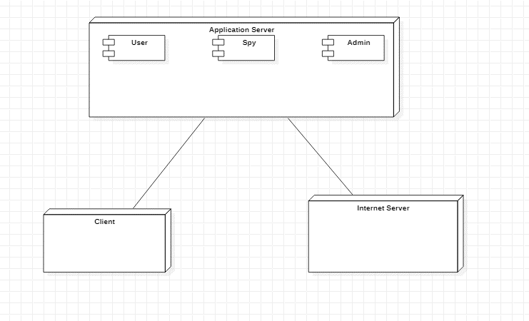

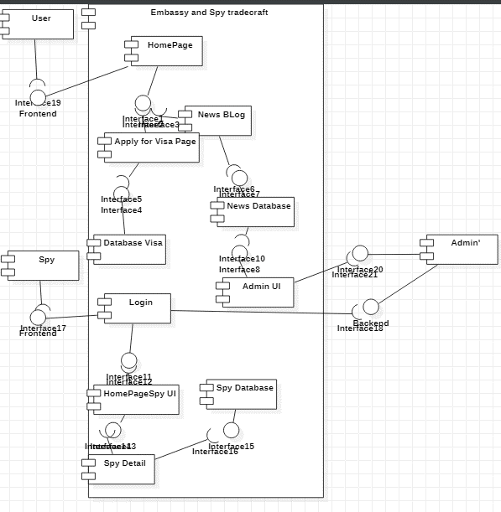

## Design Strategy

The system can be made more safe and secure by the use of cookies and various other methods. Front-end can be further beautified in future.

## Detailed System Design

### Database Design

#### ER Diagram

#### The system consists of multiple relations and tables such as users, spies, agents, diplomats, blogs, and few more entities. Most of them are interconnected to each other in 1 to 1 or 1 to many relationships.

#### 

### Application Design

### Sequence Diagram

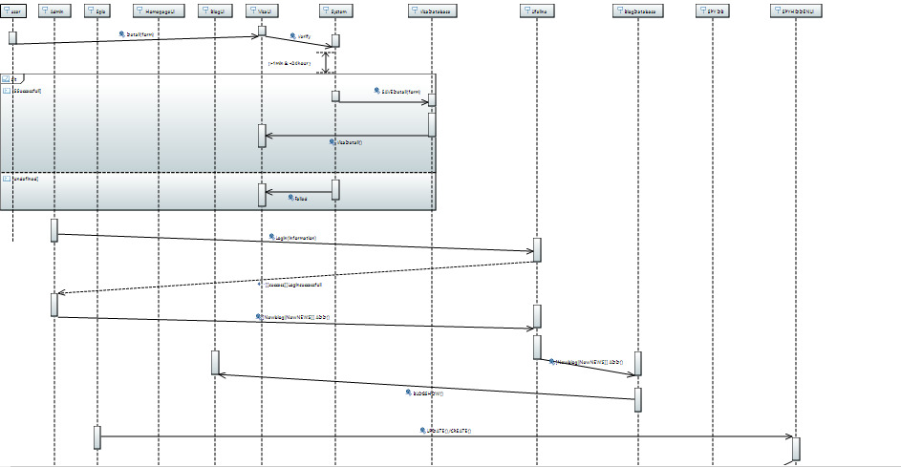

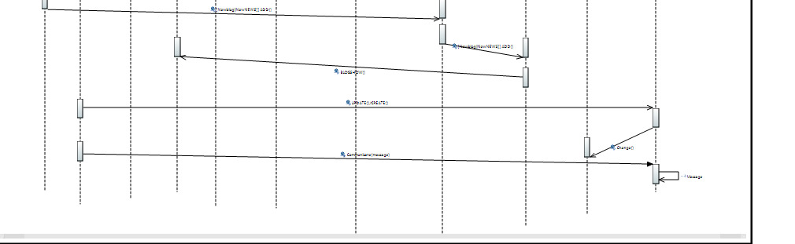

**Collaboration Diagram**

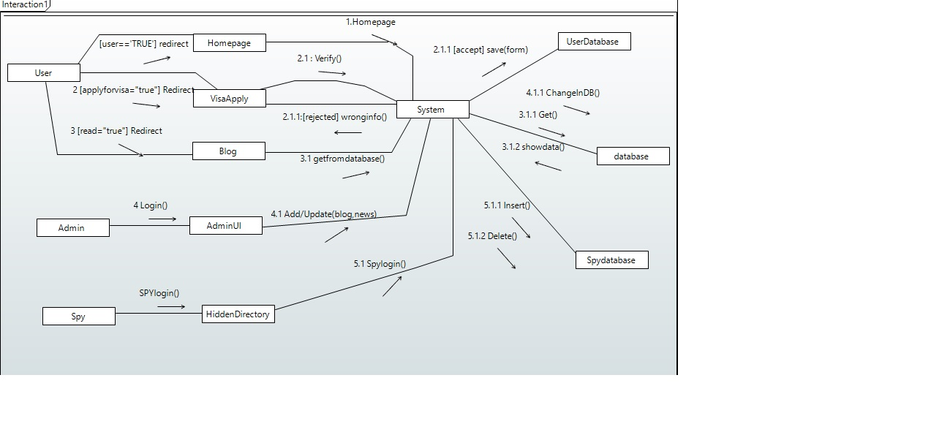

**Activity Diagram**

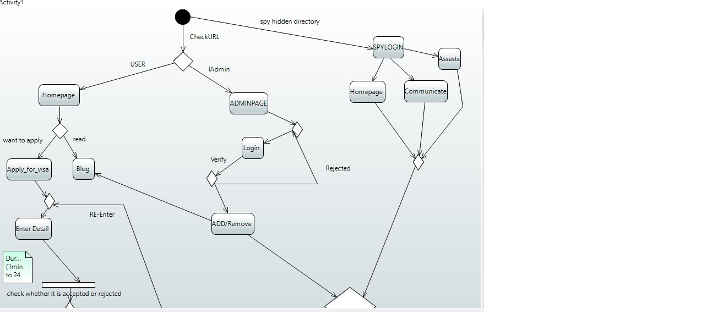

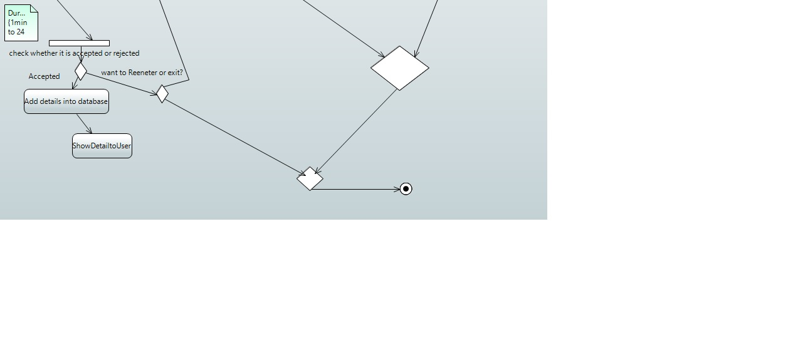

**State Diagram**

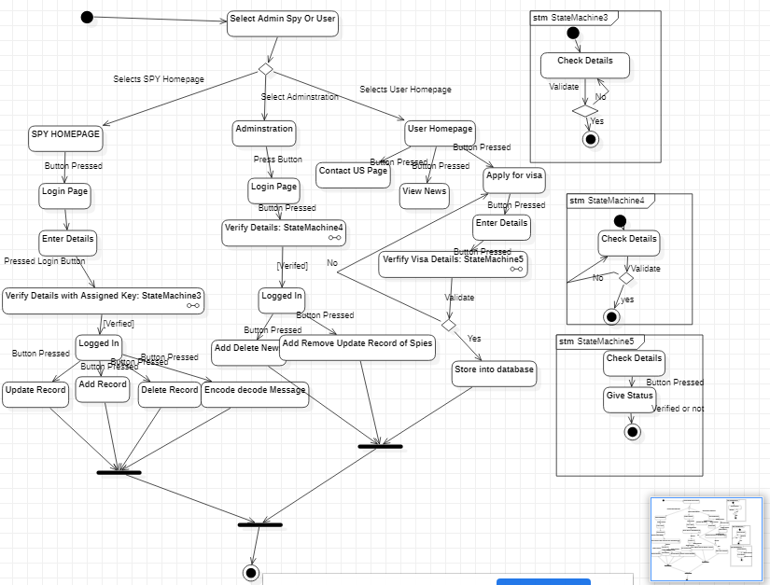

## References

None

## Appendices

GitHub repository of project: <https://github.com/vonderchild/django-emb>